
KRISHNA CLASSES

WORKSHEET
SUBJECT- MATHS
CHAPTER- 2

NAME OF STUDENT –
ISSUE DATE –
Chapter-2
- If one zero of the quadratic polynomial x² + 3x + k is 2, then the value of k is
(a) 10 (b) -10
(c) 5 (d) -5
- If one of the zeroes of the quadratic polynomial (k – 1) x² + kx + 1 is – 3, then the value of k is
- $\frac{4}{3}$ c. $\frac{-4}{3}$
- $\frac{2}{3}$ d. $\frac{-2}{3}$
- The zeroes of the quadratic polynomial $x^{2} + 99x + 127$are
(a) both positive (b) both negative
(c) one positive and one negative (d) both equal
- Which of the following is not the graph of quadratic polynomials?
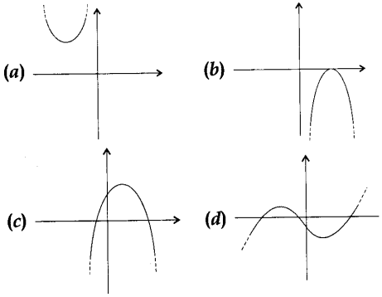
- A quadratic polynomial, whose zeros are -4 and -5, is
(a) x²-9x + 20 (b) x² + 9x + 20
(c) x²-9x- 20 (d) x² + 9x- 20
- If the zeroes of the quadratic polynomial Ax² + Bx + C, C # 0 are equal, then
(a) A and B have the same sign (b) A and C have the same sign
(c) B and C have the same sign (d) A and C have opposite signs
- If one of the zeroes of the cubic polynomial x³ + px² + qx + r is -1, then the product of the other two zeroes is
(a) p + q + 1 (b) p-q- 1
(c) q – p + 1 (d) q – p – 1
- The degree of a constant polynomial is:
a) 0 b) 1
c) 2 d) undefined
- The value of k for which the polynomial x3−3x2+kx−4 has 1 and 2 as its zeroes is:
a) 5 b) 6
c) 7 d) 8
- A quadratic polynomial, whose zeroes are -3 and 4, is
(a) x²- x + 12 (b) x² + x + 12
(c) $\frac{x^{2}}{2}-\frac{x}{2}-6$ (d) 2x² + 2x – 2
- Find the zeroes of the following quadratic polynomials and verify the relationship between the zeroes and the coefficients.
  - x²–2x –8
  - 6x²–3–7x
  - t²–15
- Find a quadratic polynomial each with the given numbers as the sum and product of its zeroes respectively.
  - 1/4, -1
  - 0, √5
  - 4, 1
- If α and β are the zeros of the quadratic polynomial $f(x)=x^{2}-x-4$, find the value of $\frac{1}{α} +\frac{1}{β} - αβ$.
- If α and β are the zeros of the quadratic polynomial f(x)=x2−p(x+1) −c, show that (α +1) (β +1) =1−c.
- Find the value of ‘k’ such that the quadratic polynomial x²−(k+6) x+2(2k+1) has sum of the zeros is half of their product.
- If the square of the difference of the zeros of the quadratic polynomial f(x)=x²+px+45 is equal to 144, find the value of p.
- Find the zeros of the polynomial $p(x)=4\sqrt{3}x^{2}+5x-2\sqrt{3}$ and verify the relationship between the zeros and its coefficients.
- If the sum of the zeros of the quadratic polynomial f(t)=kt²+2t+3k is equal to their product, find the value of k.
- If one zero of the quadratic polynomial f(x)=4x²−8kx−9 is negative of the other, find the value of ‘k’.
- If α and β are the zeros of the polynomial f(x)=x2+px+q, find polynomial whose zeros are (α+β)² and (α−β)².
- Find the value of ‘k’ so that the zeros of the quadratic polynomial 3x²−kx+14 are in the ratio 7:6.
- Find the quadratic polynomial where sum and product of the zeros are a and $\frac{1}{a}$
- Obtain all other zeroes of 3x⁴+6x³-2x²-10x-5, if two of its zeroes are √ (5/3) and – √ (5/3).
- Find a cubic polynomial with the sum, sum of the product of its zeroes taken two at a time, and the product of its zeroes as 2, –7, –14 respectively.
- If the zeroes of the polynomial x³-3x²+x+1 are a – b, a, a + b, find a and b.
- If two zeroes of the polynomial x⁴-6x³-26x²+138x-35 are 2 ±√3, find other zeroes.
- Find the value of “p” from the polynomial x² + 3x + p, if one of the zeroes of the polynomial is 2.
- Find the value of “x” in the polynomial 2a² + 2xa + 5a + 10 if (a + x) is one of its factors.
- α and β are zeroes of the quadratic polynomial x² – 6x + y. Find the value of ‘y’ if 3α + 2β = 20.
- Find a quadratic polynomial whose zeroes are reciprocals of the zeroes of the polynomial f(x) = ax² + bx + c, a ≠ 0, c ≠ 0.

